Lab AWS Storage Practices (S3,EBS, EFS, Glacier) and Backup

This lab works on Free Tier however also works AWS Academy learning lab but EFS part that part requires some permissions which you can work only in AWS Free tier.

Please capture the answer what I asked end of the this paper.

Scope of this Lab:

* AWS Storage Types
* Amazon EC2 Instance Storage (Ephemeral Storage)
* Amazon Elastic Block Storage (EBS)
* Amazon Simple Storage Service (S3)
* Amazon Elastic File System (EFS)
* Amazon S3 Glacier
* Storage Gateway ( optional , if we have time for this )

|  |  |
| --- | --- |
| Storage options for Amazon EC2 | Amazon Glacier |

**AWS Storage Types**

1. EC2 Ephemeral Storage

Many instances can access storage from disks that are physically attached to the host computer. This disk storage is referred to as instance store. Instance store provides temporary block-level storage for instances. The data on an instance store volume persists only during the life of the associated instance; if you stop or terminate an instance, any data on instance store volumes is lost.

1. Amazon EBS

Amazon EBS provides durable, block-level storage volumes that you can attach to a running instance. You can use Amazon EBS as a primary storage device for data that requires frequent and granular updates. For example, Amazon EBS is the recommended storage option when you run a database on an instance.

An EBS volume behaves like a raw, unformatted, external block device that you can attach to a single instance. The volume persists independently from the running life of an instance. After an EBS volume is attached to an instance, you can use it like any other physical hard drive. As illustrated in the previous figure, multiple volumes can be attached to an instance. You can also detach an EBS volume from one instance and attach it to another instance. You can dynamically change the configuration of a volume attached to an instance. EBS volumes can also be created as encrypted volumes using the Amazon EBS encryption feature

1. Amazon EFS

Amazon EFS provides scalable file storage for use with Amazon EC2. You can create an EFS file system and configure your instances to mount the file system. You can use an EFS file system as a common data source for workloads and applications running on multiple instance

1. Amazon S3

Amazon S3 provides access to reliable and inexpensive data storage infrastructure. It is designed to make web-scale computing easier by enabling you to store and retrieve any amount of data, at any time, from within Amazon EC2 or anywhere on the web. For example, you can use Amazon S3 to store backup copies of your data and applications. Amazon EC2 uses Amazon S3 to store EBS snapshots and instance store-backed AMIs.

1. Amazon Glacier

Glacier is an extremely low-cost storage service that provides durable storage with security features for data archiving and backup. With Glacier, customers can store their data cost effectively for months, years, or even decades. Glacier enables customers to offload the administrative burdens of operating and scaling storage to AWS, so they don't have to worry about capacity planning, hardware provisioning, data replication, hardware failure detection and recovery, or time-consuming hardware migrations

1. EC2 Ephemeral Storage

Scope: Create EC2 windows OS instance, connect to Windows machine and create “readme.first “ file on the desktop using windows notepad.( if you don’t remember the steps for EC2 please go ahead look Lab2 guide.

1. AWS EBS

During to EC2 installation there is Step 4 :ADD Storage when you select “Add New Volume” Default EBS storage show up

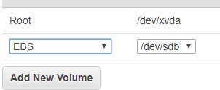

Aldo you can look into type of volume in same stage.

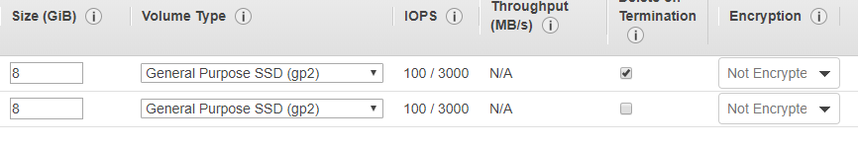

***You should know some of the terms here***

GiB: ( From Wiki)

The gibibyte is a multiple of the unit byte for digital information. The binary prefix gibi means 2^30, therefore one gibibyte is equal to 1073741824bytes = 1024 mebibytes. The unit symbol for the gibibyte is GiB. It is one of the units with binary prefixes defined by the International Electrotechnical Commission (IEC) in 1998.

The gibibyte is closely related to the gigabyte (GB), which is defined by the IEC as 10^9 bytes = 1000000000bytes, 1GiB ≈ 1.074GB. 1024 gibibytes are equal to one tebibyte. In the context of computer memory, gigabyte and GB are customarily used to mean 10243 (230) bytes, although not in the context of data transmission and not necessarily for hard drive size

Amazon EBS provides the following volume types:

* General Purpose SSD (gp2) : If your gp2 volume uses all of its I/O credit balance, the maximum IOPS performance of the volume remains at the baseline IOPS performance level (the rate at which your volume earns credits) and the volume's maximum throughput is reduced to the baseline IOPS multiplied by the maximum I/O size. Throughput can never exceed 250 MiB/s.
* Provisioned IOPS SSD (io1) : Provisioned IOPS SSD (io1) volumes are designed to meet the needs of I/O-intensive workloads, particularly database workloads, that are sensitive to storage performance and consistency. Unlike gp2, which uses a bucket and credit model to calculate performance, an io1 volume allows you to specify a consistent IOPS rate when you create the volume, and Amazon EBS delivers the provisioned IOPS performance 99.9 percent of the time.
* Throughput Optimized HDD (st1) : Throughput Optimized HDD (st1) volumes provide low-cost magnetic storage that defines performance in terms of throughput rather than IOPS. This volume type is a good fit for large, sequential workloads such as Amazon EMR, ETL, data warehouses, and log processing.
* Cold HDD (sc1) : Cold HDD (sc1) volumes provide low-cost magnetic storage that defines performance in terms of throughput rather than IOPS. With a lower throughput limit than st1, sc1 is a good fit for large, sequential cold-data workloads. If you require infrequent access to your data and are looking to save costs, sc1 provides inexpensive block storage.
* Magnetic (Standard) : Olg generation HDD solution similar as Cold HDD usally god for archiving etc.They are suited for workloads where data is accessed infrequently, and scenarios where low-cost storage for small volume sizes is important. These volumes deliver approximately 100 IOPS on average,

1. AWS EFS

1. Create your Amazon EFS file system.

2. Create your Amazon EC2 resources and launch your Amazon EC2 instance.

3. Connect to your Amazon EC2 instance and mount the Amazon EFS file system.



To create your Amazon EFS file system

1. Open the Amazon EFS Management Console from main console.

2. Choose Create File System.

3. Name is optional but you can give myefsdisk”

4. For VPC, choose your default VPC. It should look something like vpc-xxxxxxx (172.31.0.0/16)

(default). Note the VPC ID; you need it in a later step.

5.Select regional option for redundancy and Select “Create “

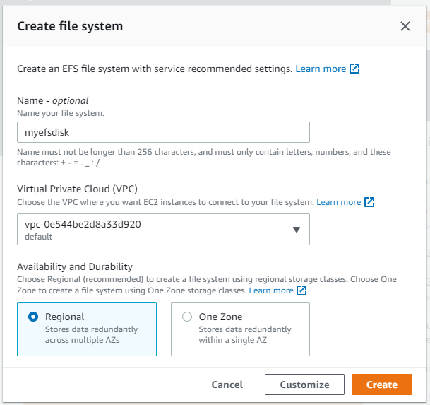

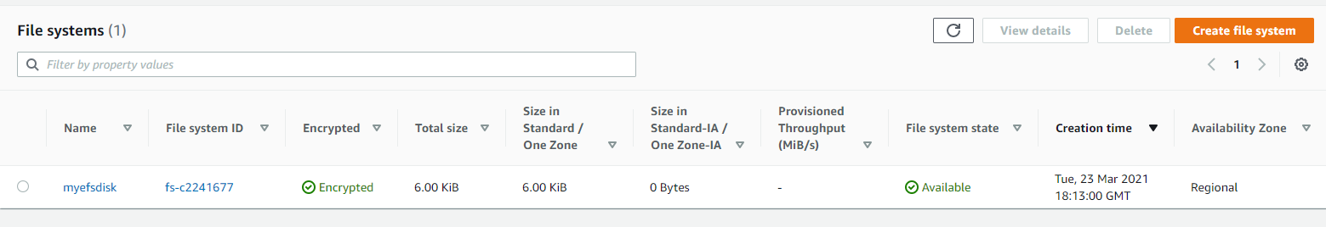

If you want to access this disk you need to goto your EC2 login the EC2 and mount it and format it before use it. ( out of scope for this lab)

4.AWS S3 (Amazon Simple Storage Service )

AWS S3 Bucket ( Object Storage)

Amazon Simple Storage Service (Amazon S3) is storage for the Internet. You can use Amazon S3 to store and retrieve any amount of data at any time, from anywhere on the web. You can accomplish these tasks using the AWS Management Console, which is a simple and intuitive web interface.

Step 1: Login to AWS Console and navigate to Storage > S3 > Create Bucket

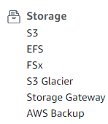

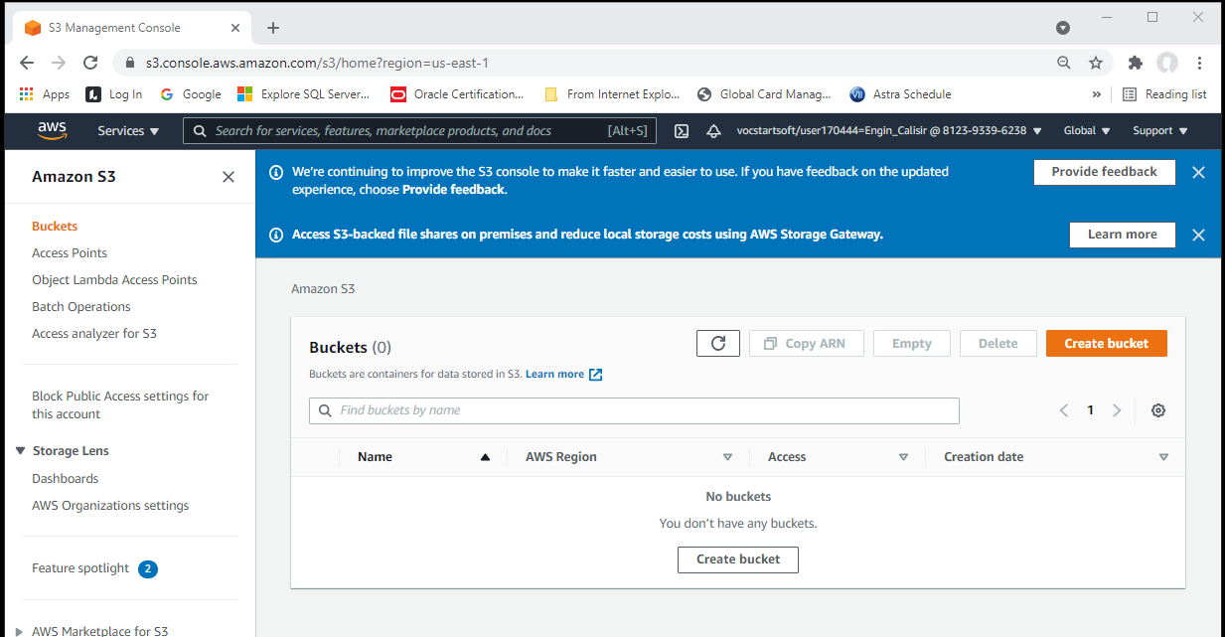

You can create your bucket here with Create button or carry on for additional configurations

Make sure your region is correct and Insert unique bucket name

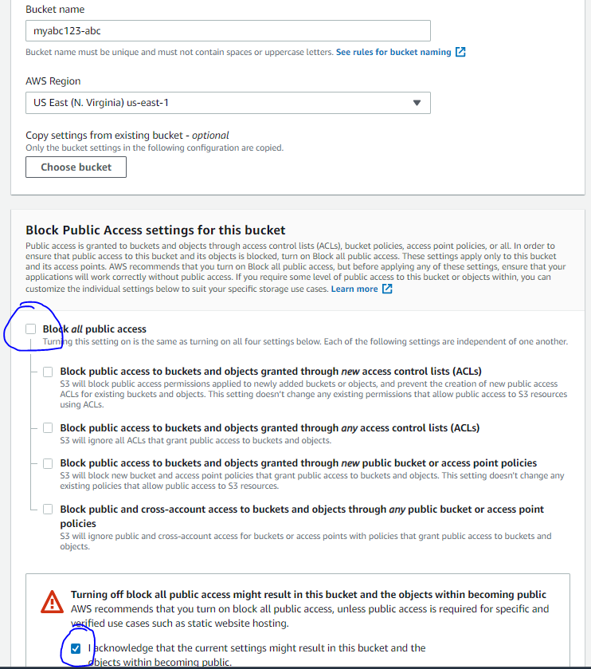

Uncheck –Block all public access and

Check I acknowledge that the current …….

For bucker versioning, go ahead enable it

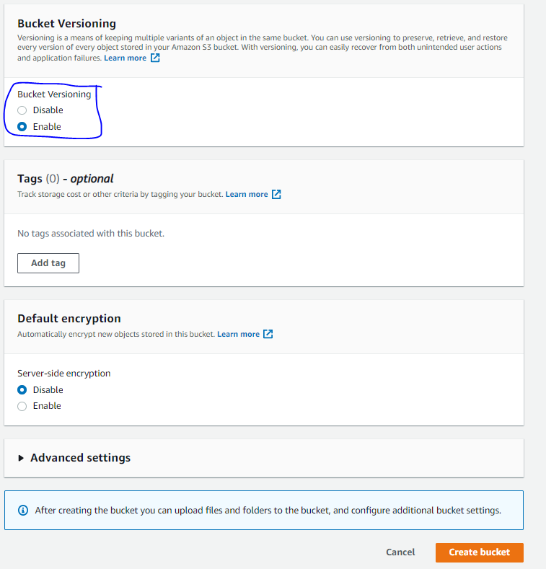

* Click Create Bucket and finish the task.

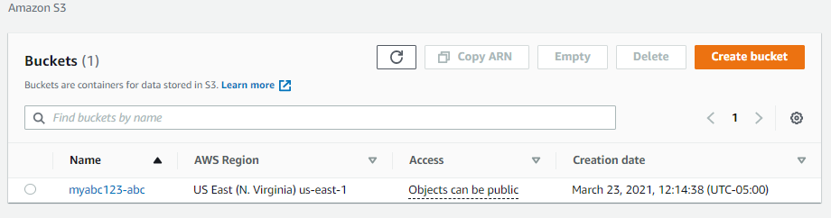

1

2

1. S3 is region wide not VPC and viewable from other region

2. Access status “ Bucket and object not public”

Step 2: click the name of you r bucket myabc123-abc is mine

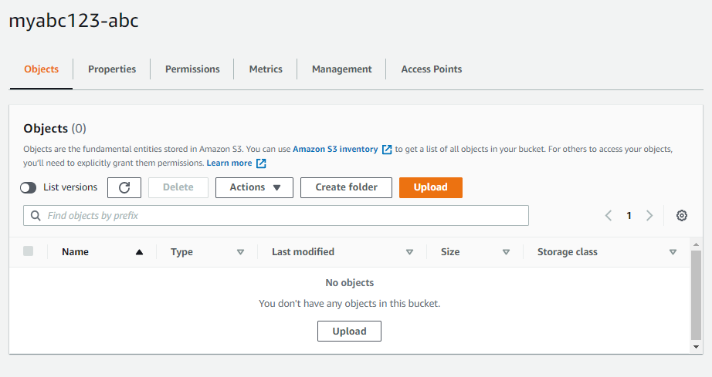

All major configuration options are here

Lets’ dig each configuration option deeply; Select Properties

## 

## 

## You can lock the object in S3 or you can enable /disable static web hosting from here

## 

## 12.1. AWS S3 Lifecycle Management

Click on **S3 Bucket** → **Management** → **Lifecycle** rules 🡪 create lifecycle rule

You can manage an objects lifecycle using this feature/rule, which defines

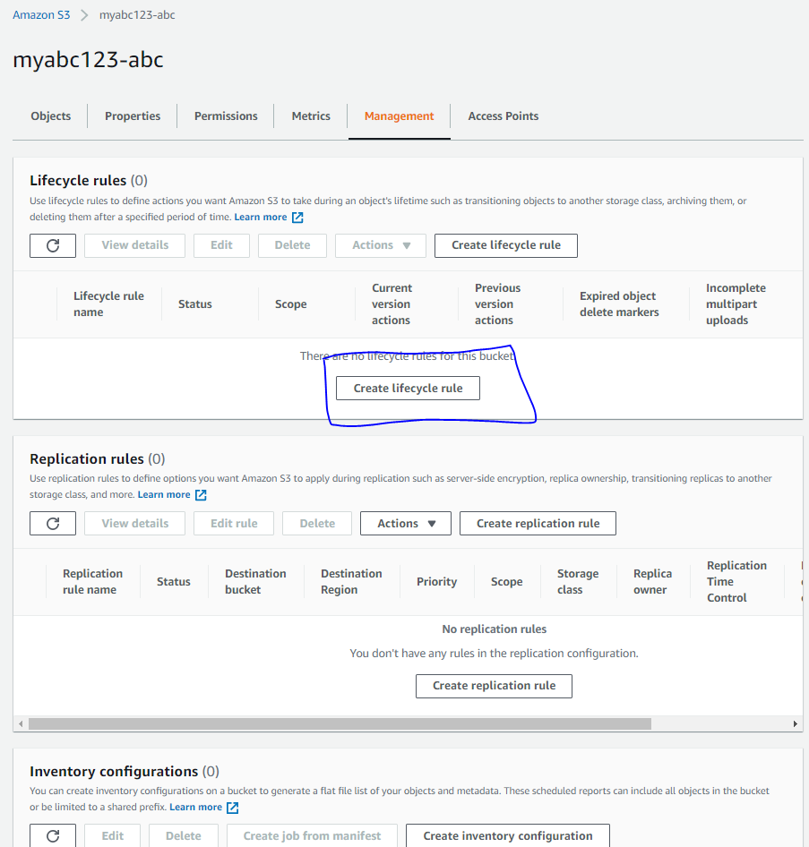

*Enter Rule Name*

Tag Name if you do not want leave it blank and goto **Lifecycle rule actions**

Based on selected versions action will be performed example if you want to keep current versions in A1 or maybe previous versions on Glacier as per your requirement

Select your prefix_

(I usally use date for prefix but this time I used “old_” prefix )

In this example I selected my current and old version of files and moved to “one zone-IA” after the 120 days later and another moved 240 days later and another 360 later and end up with Glacier (if you want to delete file you need to mark “Delete expired ,,,,,,” options

Click **Create rule**

Now let’s enable static web hosting.

Go to “Buckets” -> “Properties” -> Scroll down to “Static Web Hosting” and click “edit”. Enable it. In index document – type “index.html”. SAVE CHANGES.

Now go to “permissions” and “edit” the bucket policy.

Click on “policy generator”

Type of Policy – S3 Bucket Policy

Principal - *

Actions – “getobject”

For ARN, copy your ARN and add “/*” in the end.

ARN: <your ARN>/*

Click on “Add Statement”.

Now “Generate Policy” and copy it.

Paste in “Policy” and SAVE CHANGES. Your bucket is publicly readable now.

After it’s saved, go to “Objects” and copy URL. Open it in a browser and you should see your image.

**Questions**

**1. During the creation of EC2 Storage step when you select EBS volume type what are the available devices ( how many and name of them) also explain what is the meaning of /dev/sdb etc ?**

**2. Please provide EFS volume screenshot**

**3. Make your bucket public and insert one of the your favorite pet’s ( or any other) funny picture in there and send me the your bucket address so I can check.**

**Check mine is here ( you must make your file public therefore select file goto “actions” and select “make public” from drop down menu)**

<https://myabc123-abc.s3.amazonaws.com/jelly1.png>